Christian B. Olsson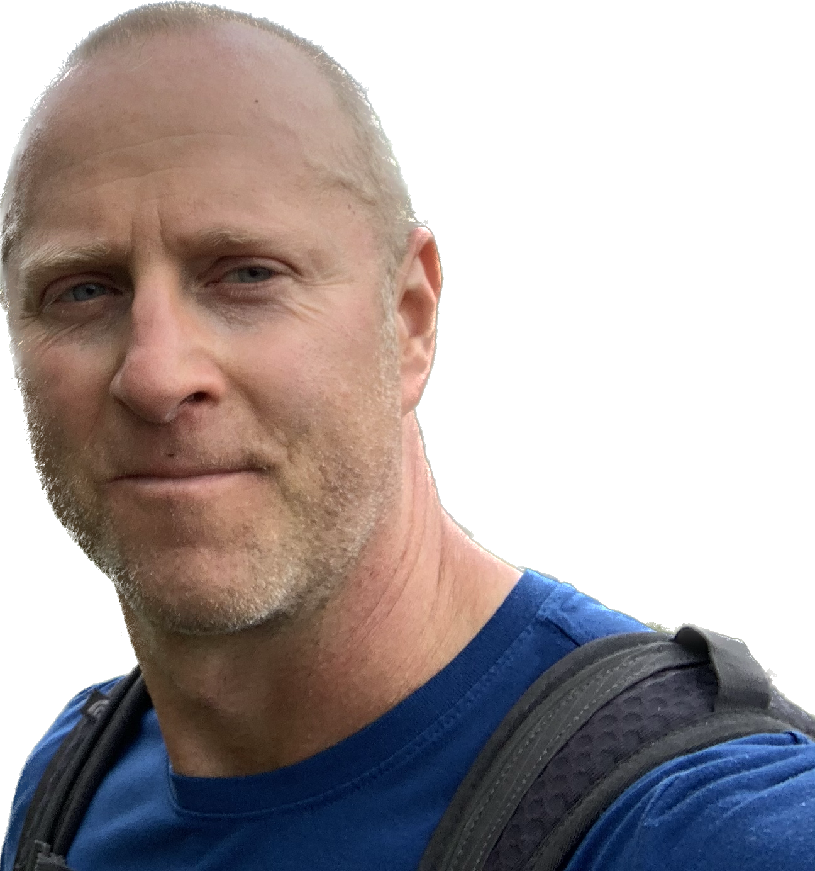

Software Developer / Architect / Manager

Schleifetobelweg 20

8810 Horgen, Switzerland

+41 79 271 02 69

[christian@codevirtuosity.com](mailto:christian@codevirtuosity.com)

[www.codevirtuosity.com](https://www.codevirtuosity.com)

linkedin.com/in/christianbolsson

**A quality- and results-driven senior software professional with demonstrated success leading teams building large-scale and business rule intensive systems.**

# SUMMARY OF QUALIFICATIONS

* 20+ years experience in Software Development, in organisations ranging from start-ups to Fortune 500 companies, in California, London, and Switzerland.
* 10 years experience leading, mentoring and managing agile software teams, developing and operating online and analytical processing systems.
* Strong ability to structure and organise teams, processes, and architecture in simple and clear ways, minimising complexity and confusion.
* Believe in leading by example, as well as empowering team members as much as possible - while understanding that ultimate responsibility can not be delegated.
* Very solid knowledge and understanding of Software Engineering patterns and fundamentals, e.g. OO Programming, Functional Programming, DDD, Refactoring, SOLID principles.
* Strong advocate of agile approaches, Clean Code, Automated Testing / TDD, Continuous Integration/Delivery/Deployment.
* Experience and expertise in a wide variety of technology paradigms, e.g. Data Engineering, Web Development, Distributed Computing / Microservices, Reactive Programming, SQL/NoSQL persistence.

# **EXPERIENCE**

## iptiQ by Swiss Re, Zurich, CH *- Engineering Manager / Tech Lead*

JAN 2020 - MAY 2023

* Led and managed stream-aligned team responsible for Claims functionality, of 5-6 frontend and backend engineers.
* Took capable, but underachieving team - due to legacy processes/organisation - to become high performing and able to deliver major business milestones within a few months, while reducing tech debt and significantly improving team morale.
* Introduced clear and repeatable Scrum like process, INVEST based user-stories, shift-left CI based dev process.
* Drove or reviewed all major system designs, implemented various parts of system. BCs generally start in “monolith first” approach, and broken out to separate services if/when needed.
* Defined and led design and implementation of generic Insurance Product model, to base Claims on. Proposed corresponding domain/services, to replace existing distributed/low-cohesion functionality.
* Introduced DDD concepts such as separation of Application and Domain logic, Rich Domain Model, Aggregates.
* Drove architecture and implementation of Micro Frontend based UIs, significantly reducing overall system complexity, as well as improving user experience.
* Drove introduction of Kafka published Domain Events via Outbox pattern, with “strangling” approach to legacy integrations - listen to our own events, and adapt as needed.
* Mentored more junior Engineering Managers in agile approaches, CI/CD best practices, system design etc.
* Main technologies: Microservices, Spring Boot, Kotlin, AWS Aurora Postgres, REST w/HATEOAS, Kafka, Typescript, React.

## Teradata, London, UK *- Software Development Practice Lead, UK & Ireland*

AUG 2018 - NOV 2019

* Led consulting practice of ~20 software developers. Responsible for staffing, resource allocation, billing targets, line management, ongoing education etc.
* Identified and developed practice direction and supporting pre-sales materials.
* Worked with Sales org on RFPs and pre-sales engagements - e.g. ML Engineering proposal for Swedish Bank, Large scale transactional system for UK Govt. Org.
* Championed practice internally via presentations to sales organisation and other practices – on topics such as DevOps, Containerisation, CI/CD, ML Engineering.
* Organised consulting wide monthly Tech Talks. Personally, held talks on Clean Code, and ML Engineering / Real Time Insurance Quote Gen. Case Study.

## Teradata, London, UK *- Principal Engineer*

JAN 2017 - JUL 2018

* At UK Insurance Company, led team on architecture, design and development of real-time platform for ML based insurance quote generation, allowing for near instantaneous model ensemble updates. Solution has served as case study and template for future ML Engineering sales efforts and engagements. Reactive Streams based micro-services implementation in Java, Spring Webflux / Reactor, Docker, AWS Aurora, ECS.
* At UK Telco, led team on Data Lake Ingestion project (Scala, Spark, Hive, HDFS), meeting very aggressive deadline. Suggested organisation-wide improvements in overall architecture and approach. Developed Scala Best Practices IP.
* At Scandinavian Bank, acted as client coordinator and architect on on-premise Data Lake infrastructure project. Proposed architectures for HA multi-DC operation of HDFS and Kafka.

## Mediaocean, London, UK *- Principal Engineer*

DEC 2014 - DEC 2016

* Proposed Kafka / Spark Streaming / Cassandra architecture for ad server performance analytics, and implemented POC to replace struggling legacy process.
* Led cross-functional team responsible for Product Catalogue system – REST driven service with web UI, handling product configuration and meta-data, with MongoDB persistence.
* Introduced and championed DDD technical patterns (rich domain model, application services etc.), leading to department wide adoption.
* Proposed architecture roadmap from existing “distributed monolith” services, to bounded-context based micro services, with separate security gateway.
* Proposed and specified detailed unit test guidelines, with department-wide rollout and adoption.
* Most common technologies: Java, Spring Boot, Hibernate, MongoDB, Oracle, RabbitMQ

## Impact Radius, London, UK *- Principal Engineer (Contractor)*

DEC 2014 - DEC 2016

* Contractor for previous employer - see below. Designed and implemented system for Product Edition and Feature management, to be able to manage tiering and differentiation across entire product suite.

## Citihub Consulting, London, UK *- Sr. Software Engineer (Contractor)*

OCT 2013 - AUG 2014

* Contractor on project at Tier-1 investment bank, with the purpose of aggregating and consolidating multi-source financial instrument meta-data, and presenting in web-interface for simple, single-point access.
* Helped achieve productivity gains and process transparency through implementing Agile process, and tool usage.

## Simply Media Network, an Estalea Company, London, UK *- Head of Engineering / Principal Engineer*

DEC 2009 - JUN 2013

* Responsible for architecture, implementation and operation of Simply Media Network applications as a very hands-on head of the engineering team.
* Led architectural overhaul and resulting implementation changes of legacy meta form generation and lead distribution system, to realise original business goal of being able to launch and operate lead generation sites without engineering involvement.
* Worked with business management to define strategy and product roadmap.

## Estalea Lp., Los Angeles / Santa Barbara, Ca *- Principal Engineer*

NOV 2005 - NOV 2009

* Worked with CTO to architect and design Impact.com system for very high web-traffic and transactional processing. Highlights include horizontally scalable transactional processing system for web events with sharded databases, and BC separated monolith, to enable possible later simple service split.
* Implemented foundation of client-facing web application and transactional processing system, as well as many other components and functionality.
* Introduced DDD based design and code standards.
* Devised and implemented automated testing strategy, with unit, integration, and UI level (Selenium) tests.

## StreamVPN / Factset, London UK *- Sr. Software Engineer*

JAN 2005 - OCT 2005

* Designed and implemented Meeting Tracker product, introduced and championed Agile Methodologies and TDD, introduced Spring Framework, Spring MVC and Hibernate.

## Commission Junction, Santa Barbara, Ca *- Software Engineer, Team Lead*

JAN 1999 - OCT 2004

* Led team of 4-6 engineers responsible for Commission Junction’s flagship product. Developed significant parts of system.

# **EDUCATION**

## Lund Institute of Technology, Lund, Sweden *- M.Sc. in Engineering Physics, 1998*

Master’s thesis project performed as visiting researcher at Dept. of Electrical and Computer Engineering, University of California, Santa Barbara.

Education abroad year as first year PhD. student in Physics, at University of California, San Diego.

# LANGUAGE SKILLS

* Swedish, Mother tongue
* English, Fluent
* French, Beginner, with five years of school education
* German, Beginner

# PERSONAL INFORMATION

* DOB: Nov 6, 1972, Marital Status: Married, Children: 1
* Interests: Freeride skiing / ski touring, Mountain Biking, Hiking, Strength and Conditioning Training, Science, Current Affairs.